What is State Transition Testing?

State Transition testing, a black box testing technique, in which outputs are triggered by changes to the input conditions or changes to 'state' of the system. In other words, tests are designed to execute valid and invalid state transitions.

When to use?

* When we have sequence of events that occur and associated conditions that apply to those events
* When the proper handling of a particular event depends on the events and conditions that have occurred in the past
* It is used for real time systems with various states and transitions involved

## Deriving Test cases:

* Understand the various state and transition and mark each valid and invalid state
* Defining a sequence of an event that leads to an allowed test ending state
* Each one of those visited state and traversed transition should be noted down
* Steps 2 and 3 should be repeated until all states have been visited and all transitions traversed
* For test cases to have a good coverage, actual input values and the actual output values have to be generated

## Advantages:

* Allows testers to familiarise with the software design and enables them to design tests effectively.
* It also enables testers to cover the unplanned or invalid states.

## Example:

A System's transition is represented as shown in the below diagram:

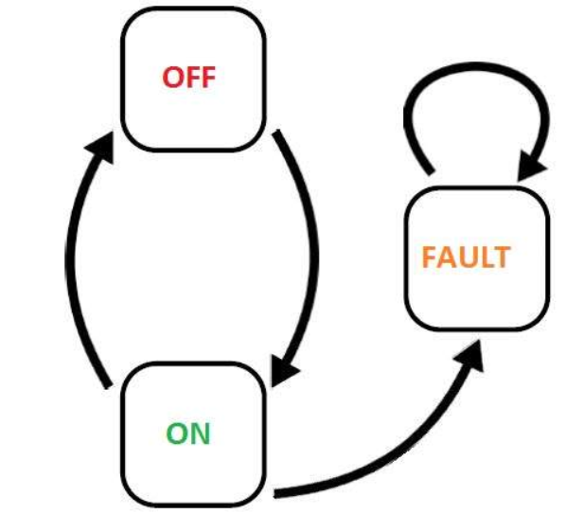

he tests are derived from the above state and transition and below are the possible scenarios that need to be tested.

|  |  |  |  |
| --- | --- | --- | --- |
| **Tests** | **Test 1** | **Test 2** | **Test 3** |
| Start State | Off | On | On |
| Input | Switch ON | Switch Off | Switch off |
| Output | Light ON | Light Off | Fault |
| Finish State | ON | OFF | On |

### **Example on State Transition Test Case Design Technique:**

Take an example of login page of an application which locks the user name after three wrong attempts of password.

A finite state system is often shown as a state diagram

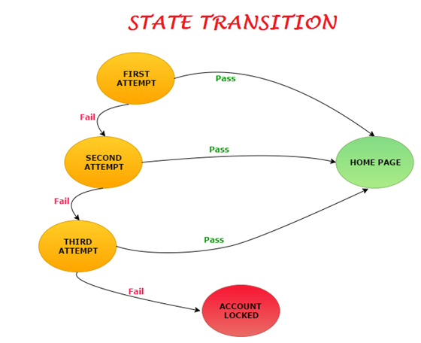

It works like a truth table. First determine the states, input data and output data.

[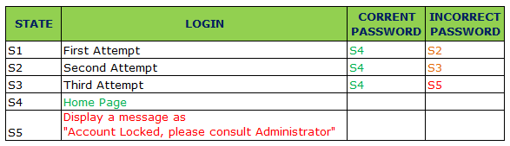](https://i2.wp.com/www.softwaretestingmaterial.com/wp-content/uploads/2016/03/State-Transition-1.png?ssl=1)

Entering correct password in the first attempt or second attempt or third attempt, user will be redirected to the home page (i.e., State – S4).

Entering incorrect correct password in the first attempt, a message will be displayed as try again and user will be redirected to state S2 for the second attempt.

Entering incorrect correct password in the second attempt, a message will be displayed as try again and user will be redirected to state S3 for the third attempt.

Entering incorrect correct password in the third attempt, user will be redirected to state S5 and a message will be displayed as “Account locked. Consult Administrator”.

Likewise, let’s see another example.

Withdrawal of money from ATM. ‘User A’ wants to withdraw 30,000 from ATM. Imagine he could take 10,000 per transaction and total balance available in the account is 25,000. In the first two attempts, he could withdraw money. Whereas in the third attempt, ATM shows a message as “Insufficient balance, contact Bank”. Same Action but due to change in the state, he couldn’t withdraw the money in the third transaction.